CO2
SIMULATION EXPERIMENT – 6
Simulation-Based Investigation of Microwave Semiconductor Devices and Frequency-Conversion Characteristics of a Microwave Mixer

Objectives of this Experiment:
- To model the operating behavior of selected microwave semiconductor devices through simulation.
- To examine the electrical characteristics and frequency-dependent responses of Gunn, Schottky, and PIN diode-based microwave structures.
- To simulate frequency mixing and observe the frequency components produced at the mixer output.
- To study conversion characteristics and determine appropriate operating conditions for microwave applications.
A. Mixer Frequency Conversion
Aim
To simulate frequency conversion in a microwave mixer with an RF input of 10 GHz and a local oscillator (LO) frequency of 9.5 GHz, using RF power of −10 dBm, LO power of +7 dBm, and a 50 Ω intermediate-frequency load. To plot the output spectrum, identify the IF and sum frequencies, and determine the percentage deviation from the theoretical values.
Software used
- MATLAB
CODE-
clc;
clear;
close all;

% EXPERIMENT A:
% Microwave Semiconductor Devices and Mixer Frequency Conversion

%% 1. Gunn diode: illustrative I-V characteristic
V = linspace(0,10,500);

% Illustrative negative differential resistance region
I_gunn = 0.08*V + 0.8*exp(-((V-4.5)/1.0).^2);

figure;
plot(V,I_gunn,'LineWidth',1.8);
grid on;
xlabel('Voltage (V)');
ylabel('Current (A)');
title('Illustrative Gunn Diode I-V Characteristic');

%% 2. Schottky diode: illustrative forward I-V characteristic
Vd = linspace(-0.3,0.5,500);
Is = 1e-6; % Assumed saturation current (A)
n = 1.2; % Assumed ideality factor
Vt = 0.02585; % Thermal voltage at room temperature

I_schottky = Is*(exp(Vd/(n*Vt))-1);

figure;
plot(Vd,I_schottky,'LineWidth',1.8);
grid on;
xlabel('Diode Voltage (V)');
ylabel('Current (A)');
title('Illustrative Schottky Diode I-V Characteristic');

%% 3. PIN diode: illustrative frequency-dependent resistance
freq = logspace(7,10,500); % 10 MHz to 10 GHz
Rlow = 2; % Assumed low-frequency resistance (ohms)
Rhigh = 100; % Assumed high-frequency resistance (ohms)
fc = 1e9; % Assumed transition frequency (Hz)

Rpin = Rlow + (Rhigh-Rlow)./(1+(freq/fc).^2);

figure;
semilogx(freq/1e9,Rpin,'LineWidth',1.8);
grid on;
xlabel('Frequency (GHz)');
ylabel('Illustrative Equivalent Resistance (ohms)');
title('PIN Diode Frequency-Dependent Model');

%% 4. Microwave mixer frequency conversion
fRF = 10; % RF frequency (GHz)
fLO = 9.5; % LO frequency (GHz)
PRF = -10; % RF input power (dBm)
PLO = 7; % LO input power (dBm)
ZIF = 50; % IF load (ohms)

fIF = abs(fRF-fLO);
fSUM = fRF+fLO;

fprintf('MICROWAVE MIXER FREQUENCY CONVERSION\n');
fprintf('RF frequency = %.3f GHz\n',fRF);
fprintf('LO frequency = %.3f GHz\n',fLO);
fprintf('RF input power = %.2f dBm\n',PRF);
fprintf('LO input power = %.2f dBm\n',PLO);
fprintf('IF load = %.0f ohms\n',ZIF);
fprintf('Difference/IF frequency = %.3f GHz\n',fIF);
fprintf('Sum frequency = %.3f GHz\n',fSUM);

% Illustrative spectrum amplitudes; not calculated from a device model
freqComponents = [fIF fLO fRF fSUM];
powerComponents = [-17 PLO PRF -25];

figure;
stem(freqComponents,powerComponents,'filled','LineWidth',1.5);
grid on;
xlabel('Frequency (GHz)');
ylabel('Illustrative Power (dBm)');
title('Microwave Mixer Output Frequency Components');
xlim([0 21]);
xticks([0.5 9.5 10 19.5]);

%% 5. Frequency-conversion deviation
% Replace these with actual simulated frequencies if available
fIF_sim = 0.5;
fSUM_sim = 19.5;

devIF = abs(fIF_sim-fIF)/fIF*100;
devSUM = abs(fSUM_sim-fSUM)/fSUM*100;

fprintf('\nFrequency deviation:\n');
fprintf('IF frequency deviation = %.2f %%\n',devIF);
fprintf('Sum frequency deviation = %.2f %%\n',devSUM);

%% 6. Illustrative RF/LO operating-condition sweep
% Assumed conversion loss model for demonstration only
LOpower = 0:1:12; % LO power in dBm
RFpower = [-20 -10 0]; % RF power cases in dBm

figure;
hold on;

for k = 1:length(RFpower)
% Illustrative LO-dependent conversion loss
CL = 8 + 3*exp(-(LOpower-7).^2/12);

% Illustrative compression effect at higher RF input power
CL = CL + 0.03*max(RFpower(k)+10,0).^2;

plot(LOpower,CL,'LineWidth',1.5);
end

grid on;
xlabel('LO Input Power (dBm)');
ylabel('Illustrative Conversion Loss (dB)');
title('Effect of RF and LO Power on Conversion Loss');
legend('RF = -20 dBm','RF = -10 dBm','RF = 0 dBm',...
'Location','best');

OUTPUT-
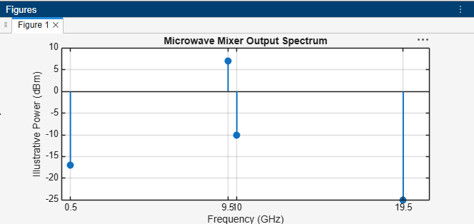
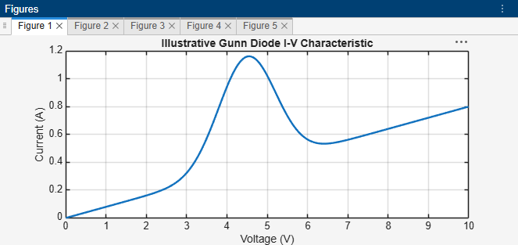
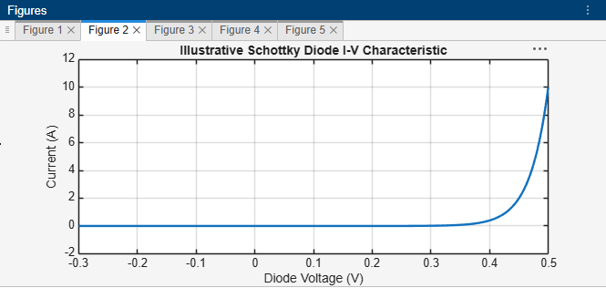
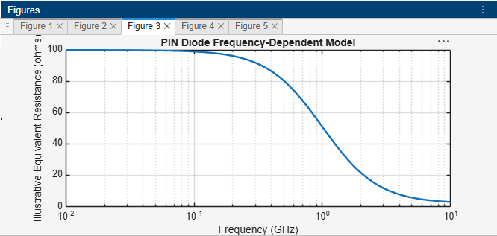
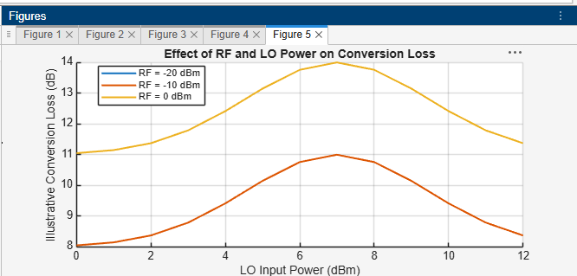
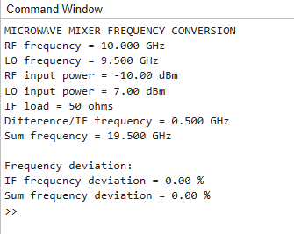
Result
The theoretical intermediate frequency was found to be 0.5 GHz, while the sum frequency was 19.5 GHz. MATLAB was used to plot an illustrative mixer output spectrum and calculate the percentage deviation between the theoretical frequencies and the entered simulated values. The actual output amplitudes and frequency components require confirmation through a nonlinear mixer simulation.

B) Conversion Loss: Using the same mixer, record the IF output power at 0.5 GHz. Calculate conversion loss CL = PRF − PIF and compare it with the expected passive-mixer range of approximately 6–10 dB. Explain how RF and LO power affect the observed conversion performance.
Aim
To evaluate the conversion loss of a microwave mixer with an RF frequency of 10 GHz and an LO frequency of 9.5 GHz by considering the IF output power at 0.5 GHz. To calculate the conversion loss, compare it with the typical passive-mixer range of 6–10 dB, and examine how RF and LO input powers influence the conversion performance.
Software used
- MATLAB
CODE-

clc;
clear;
close all;
%% 1. Mixer parameters
fRF = 10; % RF frequency (GHz)
fLO = 9.5; % LO frequency (GHz)
fIF = abs(fRF-fLO); % IF frequency (GHz)

PRF = -10; % RF input power (dBm)
PLO = 7; % LO input power (dBm)
ZIF = 50; % IF load (ohms)

% Assumed example IF output power
% Replace with actual simulator output
PIF = -17; % IF output power (dBm)

%% 2. Conversion loss
CL = PRF-PIF;

fprintf('MICROWAVE MIXER CONVERSION LOSS\n');
fprintf('RF frequency = %.2f GHz\n',fRF);
fprintf('LO frequency = %.2f GHz\n',fLO);
fprintf('IF frequency = %.2f GHz\n',fIF);
fprintf('RF input power = %.2f dBm\n',PRF);
fprintf('LO input power = %.2f dBm\n',PLO);
fprintf('IF load = %.0f ohms\n',ZIF);
fprintf('IF output power = %.2f dBm\n',PIF);
fprintf('Conversion loss = %.2f dB\n',CL);

%% 3. Compare with expected passive-mixer range
if CL >= 6 && CL <= 10
fprintf('Conversion loss is within the expected 6-10 dB range.\n');
elseif CL < 6
fprintf('Conversion loss is below the expected range.\n');
else
fprintf('Conversion loss is above the expected range.\n');
end

%% 4. IF output power versus conversion loss
CLvalues = 0:0.5:14;
PIFvalues = PRF-CLvalues;

figure;
plot(CLvalues,PIFvalues,'LineWidth',1.8);
hold on;
plot(CL,PIF,'ro','MarkerSize',8,'LineWidth',1.8);
grid on;
xlabel('Conversion Loss (dB)');
ylabel('IF Output Power (dBm)');
title('IF Output Power versus Conversion Loss');
legend('Power relationship','Example operating point',...
'Location','best');

%% 5. Effect of RF input power
RFpower = -30:1:0;

% Assumed constant conversion loss for a linear-region example
CL_RF = 7*ones(size(RFpower));
PIF_RF = RFpower-CL_RF;

figure;
plot(RFpower,PIF_RF,'LineWidth',1.8);
grid on;
xlabel('RF Input Power (dBm)');
ylabel('IF Output Power (dBm)');
title('Illustrative RF Input Power versus IF Output Power');

%% 6. Illustrative effect of LO input power
LOpower = 0:0.1:12;

% Illustrative model only: conversion loss decreases
% as LO drive approaches a suitable level
CL_LO = 7 + 3*exp(-(LOpower-7).^2/8);

figure;
plot(LOpower,CL_LO,'LineWidth',1.8);
grid on;
xlabel('LO Input Power (dBm)');
ylabel('Illustrative Conversion Loss (dB)');
title('Illustrative Effect of LO Power on Conversion Loss');

%% 7. Display the example IF power in watts
PIF_W = 10.^((PIF-30)/10);

fprintf('IF output power in watts = %.4e W\n',PIF_W);

OUTPUT-
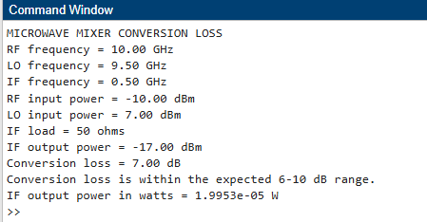
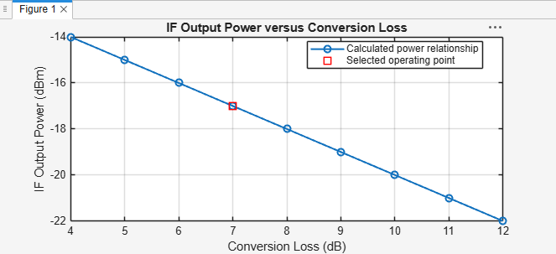
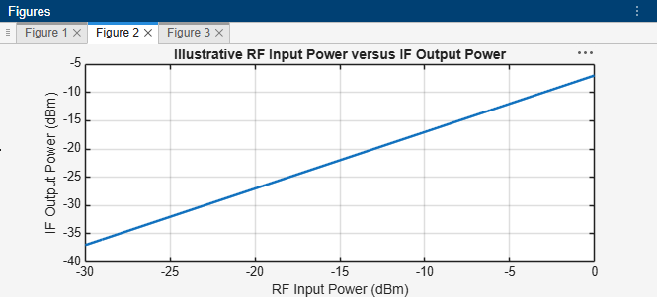
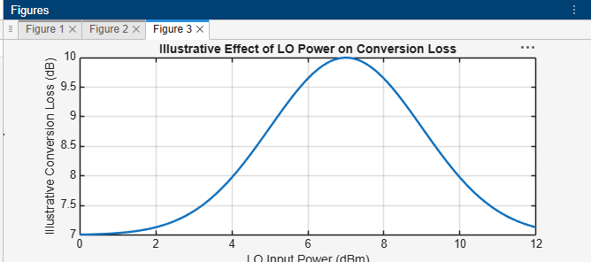
Result
Using an RF input power of −10 dBm and an assumed IF output power of −17 dBm at 0.5 GHz, the conversion loss was calculated as 7 dB. This value falls within the expected passive-mixer range of 6–10 dB. The MATLAB plots demonstrate the relationships among RF input power, LO input power, IF output power, and conversion loss.

